**Steps for Database Sample (mongoose)**

1. Install
   1. npm install express body-parser mongoose --save
2. Create main.js
3. Create a folder config
   1. Create a file database_config.js in it
4. Create a Folder app
5. Create a folder models in app folder
6. Create a folder controller in app folder
7. Create a folder routes in app folder
8. Create a file studmodel.js in model folder
9. Create a file studcontroller.js in controller folder
10. Create a file stud.routes.js in routes folder

To Insert a Document

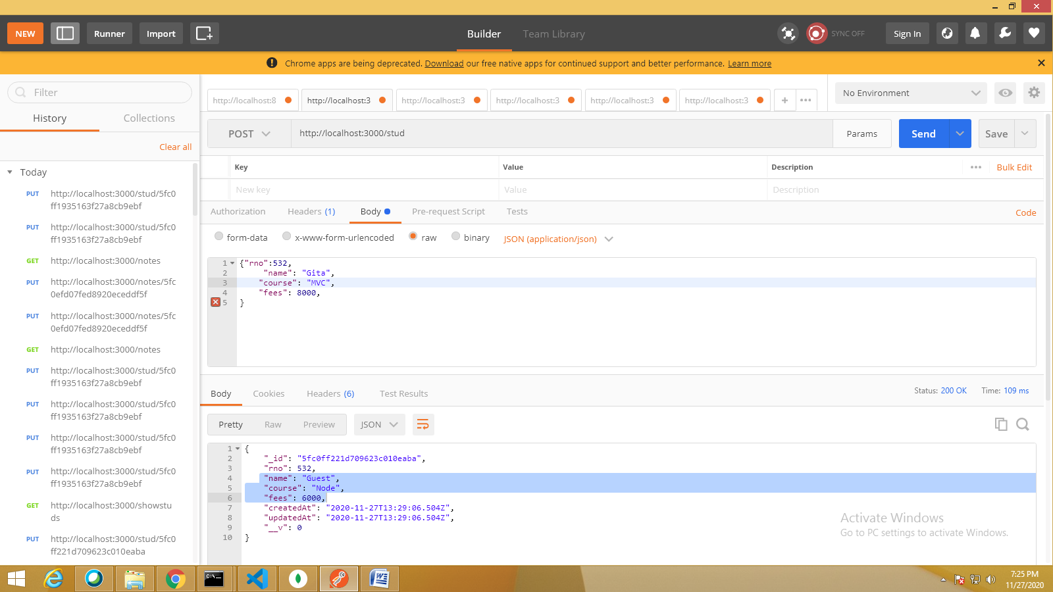

To Retrieve all Students

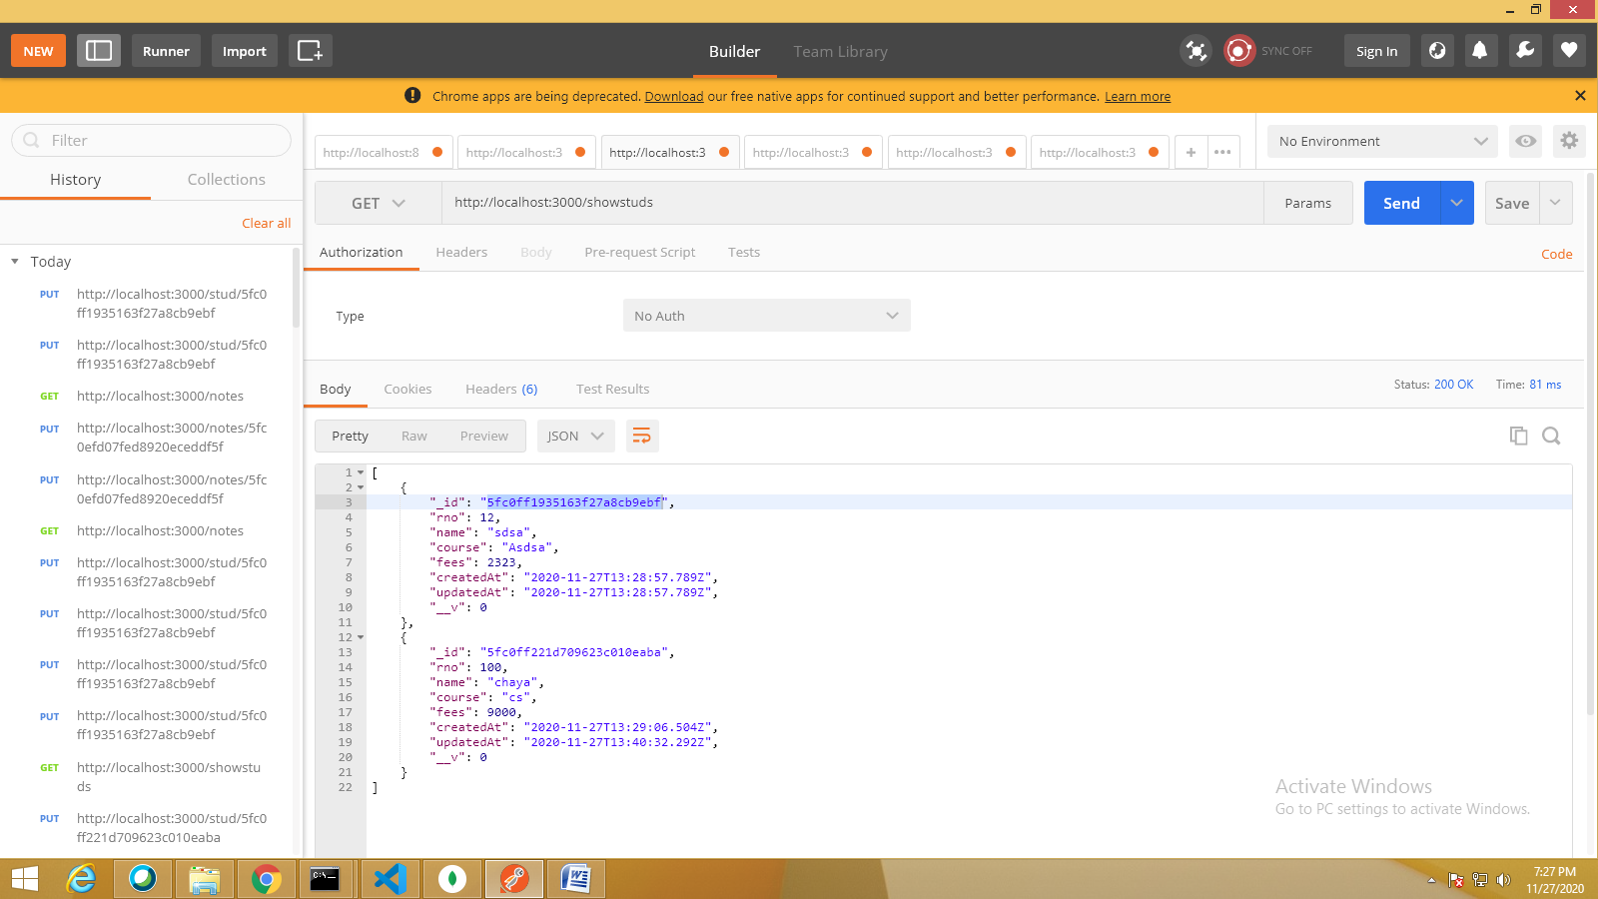

To Delete a Student

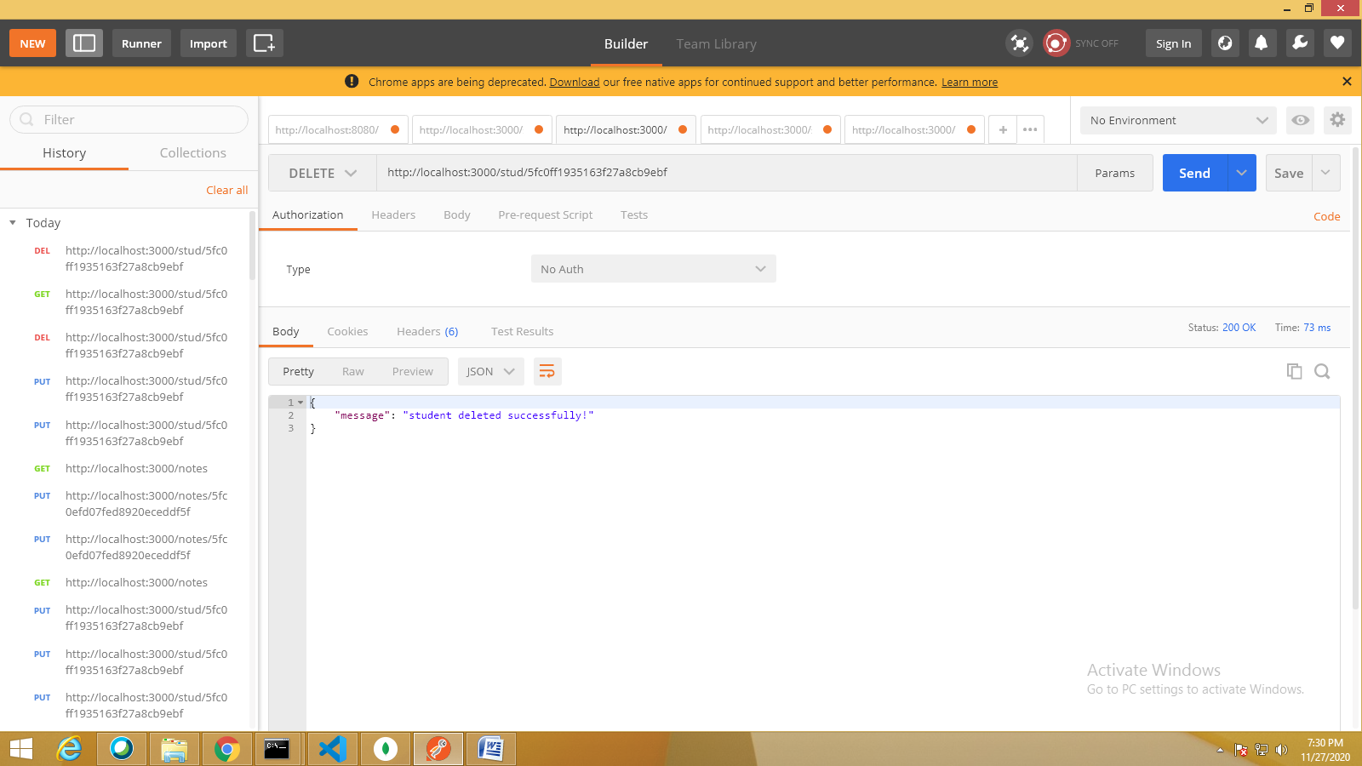

To Update a Student

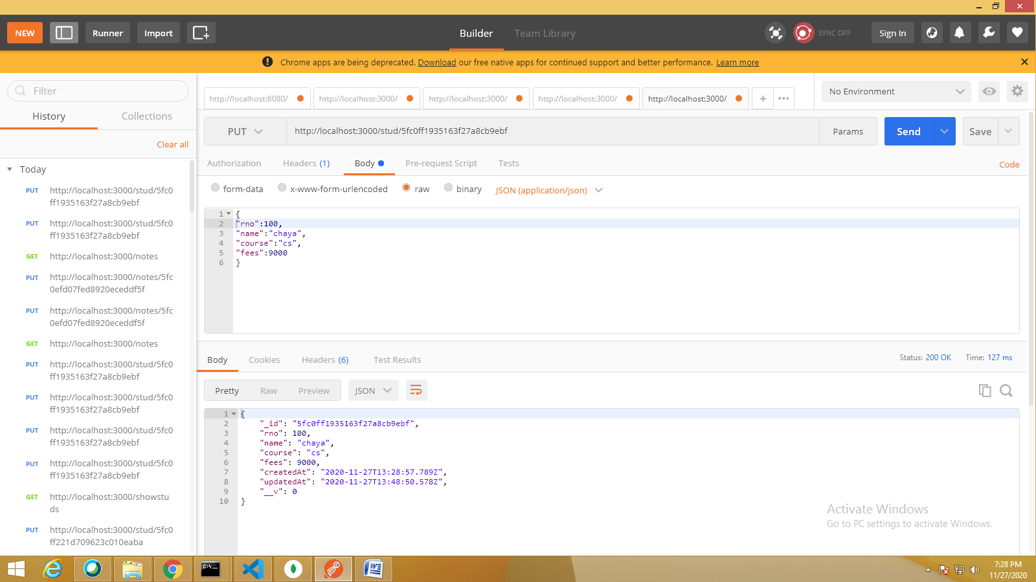

To Search a Student

